**P Jeevesh Naidu 211105039**

**1. 0/1 knapsack dynamic programming**

Input/output:

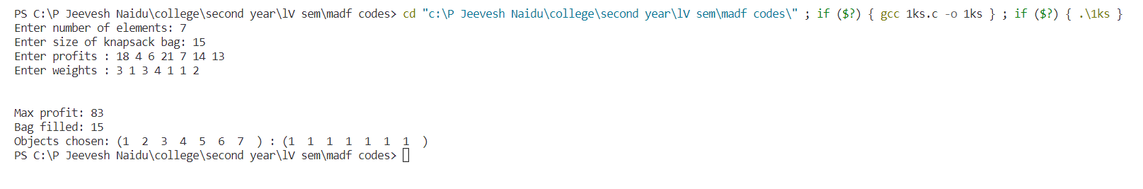

**2. n-queens**

4 queens

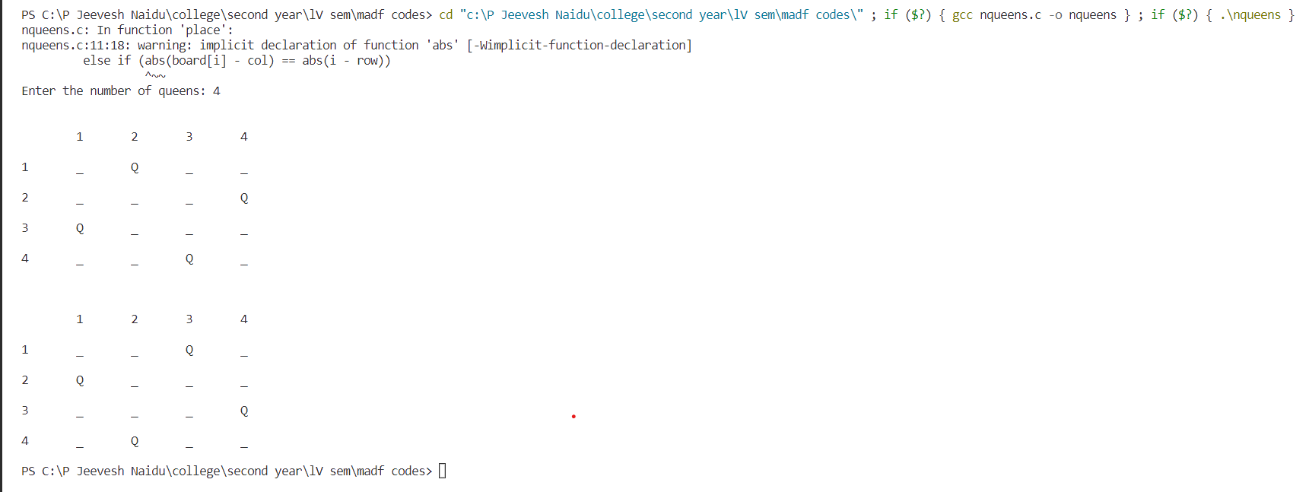

**3. sum of subsets:**

Input/output

1]ascending order

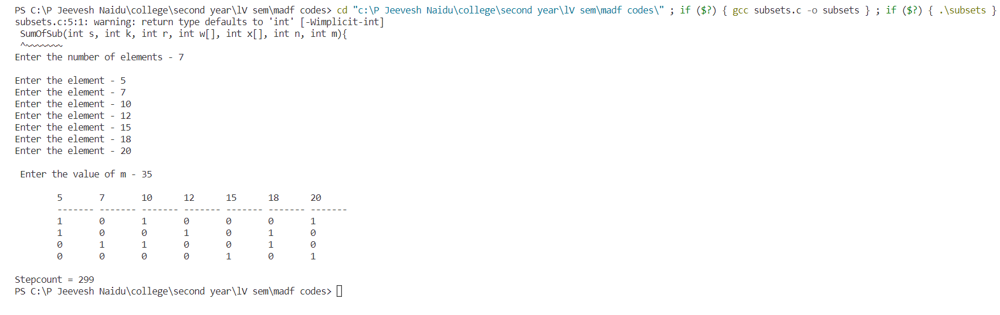

2]descending order

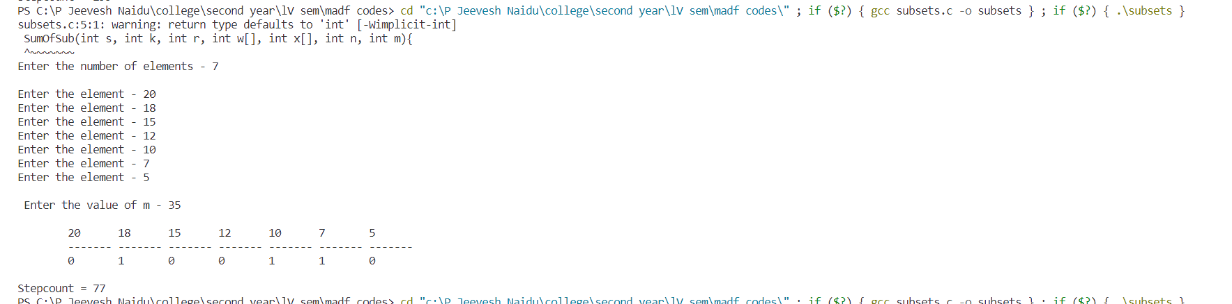

3] random order

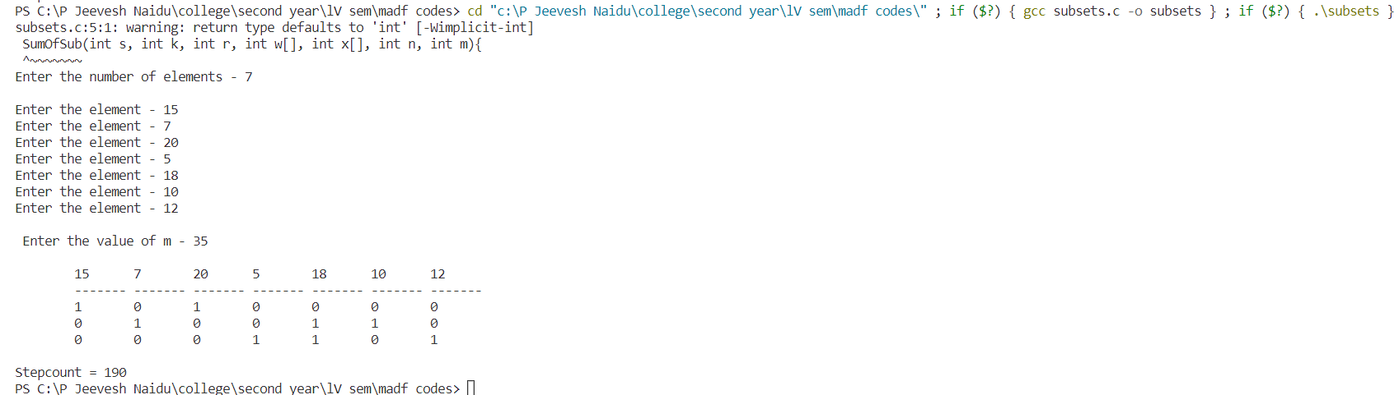

**4. m-colouring**:

input/output:

1]

PS C:\P Jeevesh Naidu\college\second year\lV sem\madf codes> cd "c:\P Jeevesh Naidu\college\second year\lV sem\madf codes\" ; if ($?) { gcc mclouring.c -o mclouring } ; if ($?) { .\mclouring }

Enter number of vertices: 10

Enter number of edges: 10

Enter edges:

Enter the u and v edge:

1 2

1 3

1 4

3 4

2 4

5 6

5 7

6 7

8 9

9 10

Enter number of colors: 3

The Solutions are:

Solution 1 - 1 2 2 3 1 2 3 1 2 1

Solution 2 - 1 2 2 3 1 2 3 1 2 3

Solution 3 - 1 2 2 3 1 2 3 1 3 1

Solution 4 - 1 2 2 3 1 2 3 1 3 2

Solution 5 - 1 2 2 3 1 2 3 2 1 2

Solution 6 - 1 2 2 3 1 2 3 2 1 3

Solution 7 - 1 2 2 3 1 2 3 2 3 1

Solution 8 - 1 2 2 3 1 2 3 2 3 2

Solution 9 - 1 2 2 3 1 2 3 3 1 2

Solution 10 - 1 2 2 3 1 2 3 3 1 3

Solution 11 - 1 2 2 3 1 2 3 3 2 1

Solution 12 - 1 2 2 3 1 2 3 3 2 3

Solution 13 - 1 2 2 3 1 3 2 1 2 1

Solution 14 - 1 2 2 3 1 3 2 1 2 3

Solution 15 - 1 2 2 3 1 3 2 1 3 1

Solution 16 - 1 2 2 3 1 3 2 1 3 2

Solution 17 - 1 2 2 3 1 3 2 2 1 2

Solution 18 - 1 2 2 3 1 3 2 2 1 3

Solution 19 - 1 2 2 3 1 3 2 2 3 1

Solution 20 - 1 2 2 3 1 3 2 2 3 2

Solution 21 - 1 2 2 3 1 3 2 3 1 2

Solution 22 - 1 2 2 3 1 3 2 3 1 3

Solution 23 - 1 2 2 3 1 3 2 3 2 1

Solution 24 - 1 2 2 3 1 3 2 3 2 3

Solution 25 - 1 2 2 3 2 1 3 1 2 1

Solution 26 - 1 2 2 3 2 1 3 1 2 3

Solution 27 - 1 2 2 3 2 1 3 1 3 1

Solution 28 - 1 2 2 3 2 1 3 1 3 2

Solution 29 - 1 2 2 3 2 1 3 2 1 2

Solution 30 - 1 2 2 3 2 1 3 2 1 3

Solution 31 - 1 2 2 3 2 1 3 2 3 1

Solution 32 - 1 2 2 3 2 1 3 2 3 2

Solution 33 - 1 2 2 3 2 1 3 3 1 2

Solution 34 - 1 2 2 3 2 1 3 3 1 3

Solution 35 - 1 2 2 3 2 1 3 3 2 1

Solution 36 - 1 2 2 3 2 1 3 3 2 3

Solution 37 - 1 2 2 3 2 3 1 1 2 1

Solution 38 - 1 2 2 3 2 3 1 1 2 3

Solution 39 - 1 2 2 3 2 3 1 1 3 1

Solution 40 - 1 2 2 3 2 3 1 1 3 2

Solution 41 - 1 2 2 3 2 3 1 2 1 2

Solution 42 - 1 2 2 3 2 3 1 2 1 3

Solution 43 - 1 2 2 3 2 3 1 2 3 1

Solution 44 - 1 2 2 3 2 3 1 2 3 2

Solution 45 - 1 2 2 3 2 3 1 3 1 2

Solution 46 - 1 2 2 3 2 3 1 3 1 3

Solution 47 - 1 2 2 3 2 3 1 3 2 1

Solution 48 - 1 2 2 3 2 3 1 3 2 3

Solution 49 - 1 2 2 3 3 1 2 1 2 1

Solution 50 - 1 2 2 3 3 1 2 1 2 3

Solution 51 - 1 2 2 3 3 1 2 1 3 1

Solution 52 - 1 2 2 3 3 1 2 1 3 2

Solution 53 - 1 2 2 3 3 1 2 2 1 2

Solution 54 - 1 2 2 3 3 1 2 2 1 3

Solution 55 - 1 2 2 3 3 1 2 2 3 1

Solution 56 - 1 2 2 3 3 1 2 2 3 2

Solution 57 - 1 2 2 3 3 1 2 3 1 2

Solution 58 - 1 2 2 3 3 1 2 3 1 3

Solution 59 - 1 2 2 3 3 1 2 3 2 1

Solution 60 - 1 2 2 3 3 1 2 3 2 3

Solution 61 - 1 2 2 3 3 2 1 1 2 1

Solution 62 - 1 2 2 3 3 2 1 1 2 3

Solution 63 - 1 2 2 3 3 2 1 1 3 1

Solution 64 - 1 2 2 3 3 2 1 1 3 2

Solution 65 - 1 2 2 3 3 2 1 2 1 2

Solution 66 - 1 2 2 3 3 2 1 2 1 3

Solution 67 - 1 2 2 3 3 2 1 2 3 1

Solution 68 - 1 2 2 3 3 2 1 2 3 2

Solution 69 - 1 2 2 3 3 2 1 3 1 2

Solution 70 - 1 2 2 3 3 2 1 3 1 3

Solution 71 - 1 2 2 3 3 2 1 3 2 1

Solution 72 - 1 2 2 3 3 2 1 3 2 3

Solution 73 - 1 3 3 2 1 2 3 1 2 1

Solution 74 - 1 3 3 2 1 2 3 1 2 3

Solution 75 - 1 3 3 2 1 2 3 1 3 1

Solution 76 - 1 3 3 2 1 2 3 1 3 2

Solution 77 - 1 3 3 2 1 2 3 2 1 2

Solution 78 - 1 3 3 2 1 2 3 2 1 3

Solution 79 - 1 3 3 2 1 2 3 2 3 1

Solution 80 - 1 3 3 2 1 2 3 2 3 2

Solution 81 - 1 3 3 2 1 2 3 3 1 2

Solution 82 - 1 3 3 2 1 2 3 3 1 3

Solution 83 - 1 3 3 2 1 2 3 3 2 1

Solution 84 - 1 3 3 2 1 2 3 3 2 3

Solution 85 - 1 3 3 2 1 3 2 1 2 1

Solution 86 - 1 3 3 2 1 3 2 1 2 3

Solution 87 - 1 3 3 2 1 3 2 1 3 1

Solution 88 - 1 3 3 2 1 3 2 1 3 2

Solution 89 - 1 3 3 2 1 3 2 2 1 2

Solution 90 - 1 3 3 2 1 3 2 2 1 3

Solution 91 - 1 3 3 2 1 3 2 2 3 1

Solution 92 - 1 3 3 2 1 3 2 2 3 2

Solution 93 - 1 3 3 2 1 3 2 3 1 2

Solution 94 - 1 3 3 2 1 3 2 3 1 3

Solution 95 - 1 3 3 2 1 3 2 3 2 1

Solution 96 - 1 3 3 2 1 3 2 3 2 3

Solution 97 - 1 3 3 2 2 1 3 1 2 1

Solution 98 - 1 3 3 2 2 1 3 1 2 3

Solution 99 - 1 3 3 2 2 1 3 1 3 1

Solution 100 - 1 3 3 2 2 1 3 1 3 2

Solution 101 - 1 3 3 2 2 1 3 2 1 2

Solution 102 - 1 3 3 2 2 1 3 2 1 3

Solution 103 - 1 3 3 2 2 1 3 2 3 1

Solution 104 - 1 3 3 2 2 1 3 2 3 2

Solution 105 - 1 3 3 2 2 1 3 3 1 2

Solution 106 - 1 3 3 2 2 1 3 3 1 3

Solution 107 - 1 3 3 2 2 1 3 3 2 1

Solution 108 - 1 3 3 2 2 1 3 3 2 3

Solution 109 - 1 3 3 2 2 3 1 1 2 1

Solution 110 - 1 3 3 2 2 3 1 1 2 3

Solution 111 - 1 3 3 2 2 3 1 1 3 1

Solution 112 - 1 3 3 2 2 3 1 1 3 2

Solution 113 - 1 3 3 2 2 3 1 2 1 2

Solution 114 - 1 3 3 2 2 3 1 2 1 3

Solution 115 - 1 3 3 2 2 3 1 2 3 1

Solution 116 - 1 3 3 2 2 3 1 2 3 2

Solution 117 - 1 3 3 2 2 3 1 3 1 2

Solution 118 - 1 3 3 2 2 3 1 3 1 3

Solution 119 - 1 3 3 2 2 3 1 3 2 1

Solution 120 - 1 3 3 2 2 3 1 3 2 3

Solution 121 - 1 3 3 2 3 1 2 1 2 1

Solution 122 - 1 3 3 2 3 1 2 1 2 3

Solution 123 - 1 3 3 2 3 1 2 1 3 1

Solution 124 - 1 3 3 2 3 1 2 1 3 2

Solution 125 - 1 3 3 2 3 1 2 2 1 2

Solution 126 - 1 3 3 2 3 1 2 2 1 3

Solution 127 - 1 3 3 2 3 1 2 2 3 1

Solution 128 - 1 3 3 2 3 1 2 2 3 2

Solution 129 - 1 3 3 2 3 1 2 3 1 2

Solution 130 - 1 3 3 2 3 1 2 3 1 3

Solution 131 - 1 3 3 2 3 1 2 3 2 1

Solution 132 - 1 3 3 2 3 1 2 3 2 3

Solution 133 - 1 3 3 2 3 2 1 1 2 1

Solution 134 - 1 3 3 2 3 2 1 1 2 3

Solution 135 - 1 3 3 2 3 2 1 1 3 1

Solution 136 - 1 3 3 2 3 2 1 1 3 2

Solution 137 - 1 3 3 2 3 2 1 2 1 2

Solution 138 - 1 3 3 2 3 2 1 2 1 3

Solution 139 - 1 3 3 2 3 2 1 2 3 1

Solution 140 - 1 3 3 2 3 2 1 2 3 2

Solution 141 - 1 3 3 2 3 2 1 3 1 2

Solution 142 - 1 3 3 2 3 2 1 3 1 3

Solution 143 - 1 3 3 2 3 2 1 3 2 1

Solution 144 - 1 3 3 2 3 2 1 3 2 3

Solution 145 - 2 1 1 3 1 2 3 1 2 1

Solution 146 - 2 1 1 3 1 2 3 1 2 3

Solution 147 - 2 1 1 3 1 2 3 1 3 1

Solution 148 - 2 1 1 3 1 2 3 1 3 2

Solution 149 - 2 1 1 3 1 2 3 2 1 2

Solution 150 - 2 1 1 3 1 2 3 2 1 3

Solution 151 - 2 1 1 3 1 2 3 2 3 1

Solution 152 - 2 1 1 3 1 2 3 2 3 2

Solution 153 - 2 1 1 3 1 2 3 3 1 2

Solution 154 - 2 1 1 3 1 2 3 3 1 3

Solution 155 - 2 1 1 3 1 2 3 3 2 1

Solution 156 - 2 1 1 3 1 2 3 3 2 3

Solution 157 - 2 1 1 3 1 3 2 1 2 1

Solution 158 - 2 1 1 3 1 3 2 1 2 3

Solution 159 - 2 1 1 3 1 3 2 1 3 1

Solution 160 - 2 1 1 3 1 3 2 1 3 2

Solution 161 - 2 1 1 3 1 3 2 2 1 2

Solution 162 - 2 1 1 3 1 3 2 2 1 3

Solution 163 - 2 1 1 3 1 3 2 2 3 1

Solution 164 - 2 1 1 3 1 3 2 2 3 2

Solution 165 - 2 1 1 3 1 3 2 3 1 2

Solution 166 - 2 1 1 3 1 3 2 3 1 3

Solution 167 - 2 1 1 3 1 3 2 3 2 1

Solution 168 - 2 1 1 3 1 3 2 3 2 3

Solution 169 - 2 1 1 3 2 1 3 1 2 1

Solution 170 - 2 1 1 3 2 1 3 1 2 3

Solution 171 - 2 1 1 3 2 1 3 1 3 1

Solution 172 - 2 1 1 3 2 1 3 1 3 2

Solution 173 - 2 1 1 3 2 1 3 2 1 2

Solution 174 - 2 1 1 3 2 1 3 2 1 3

Solution 175 - 2 1 1 3 2 1 3 2 3 1

Solution 176 - 2 1 1 3 2 1 3 2 3 2

Solution 177 - 2 1 1 3 2 1 3 3 1 2

Solution 178 - 2 1 1 3 2 1 3 3 1 3

Solution 179 - 2 1 1 3 2 1 3 3 2 1

Solution 180 - 2 1 1 3 2 1 3 3 2 3

Solution 181 - 2 1 1 3 2 3 1 1 2 1

Solution 182 - 2 1 1 3 2 3 1 1 2 3

Solution 183 - 2 1 1 3 2 3 1 1 3 1

Solution 184 - 2 1 1 3 2 3 1 1 3 2

Solution 185 - 2 1 1 3 2 3 1 2 1 2

Solution 186 - 2 1 1 3 2 3 1 2 1 3

Solution 187 - 2 1 1 3 2 3 1 2 3 1

Solution 188 - 2 1 1 3 2 3 1 2 3 2

Solution 189 - 2 1 1 3 2 3 1 3 1 2

Solution 190 - 2 1 1 3 2 3 1 3 1 3

Solution 191 - 2 1 1 3 2 3 1 3 2 1

Solution 192 - 2 1 1 3 2 3 1 3 2 3

Solution 193 - 2 1 1 3 3 1 2 1 2 1

Solution 194 - 2 1 1 3 3 1 2 1 2 3

Solution 195 - 2 1 1 3 3 1 2 1 3 1

Solution 196 - 2 1 1 3 3 1 2 1 3 2

Solution 197 - 2 1 1 3 3 1 2 2 1 2

Solution 198 - 2 1 1 3 3 1 2 2 1 3

Solution 199 - 2 1 1 3 3 1 2 2 3 1

Solution 200 - 2 1 1 3 3 1 2 2 3 2

Solution 201 - 2 1 1 3 3 1 2 3 1 2

Solution 202 - 2 1 1 3 3 1 2 3 1 3

Solution 203 - 2 1 1 3 3 1 2 3 2 1

Solution 204 - 2 1 1 3 3 1 2 3 2 3

Solution 205 - 2 1 1 3 3 2 1 1 2 1

Solution 206 - 2 1 1 3 3 2 1 1 2 3

Solution 207 - 2 1 1 3 3 2 1 1 3 1

Solution 208 - 2 1 1 3 3 2 1 1 3 2

Solution 209 - 2 1 1 3 3 2 1 2 1 2

Solution 210 - 2 1 1 3 3 2 1 2 1 3

Solution 211 - 2 1 1 3 3 2 1 2 3 1

Solution 212 - 2 1 1 3 3 2 1 2 3 2

Solution 213 - 2 1 1 3 3 2 1 3 1 2

Solution 214 - 2 1 1 3 3 2 1 3 1 3

Solution 215 - 2 1 1 3 3 2 1 3 2 1

Solution 216 - 2 1 1 3 3 2 1 3 2 3

Solution 217 - 2 3 3 1 1 2 3 1 2 1

Solution 218 - 2 3 3 1 1 2 3 1 2 3

Solution 219 - 2 3 3 1 1 2 3 1 3 1

Solution 220 - 2 3 3 1 1 2 3 1 3 2

Solution 221 - 2 3 3 1 1 2 3 2 1 2

Solution 222 - 2 3 3 1 1 2 3 2 1 3

Solution 223 - 2 3 3 1 1 2 3 2 3 1

Solution 224 - 2 3 3 1 1 2 3 2 3 2

Solution 225 - 2 3 3 1 1 2 3 3 1 2

Solution 226 - 2 3 3 1 1 2 3 3 1 3

Solution 227 - 2 3 3 1 1 2 3 3 2 1

Solution 228 - 2 3 3 1 1 2 3 3 2 3

Solution 229 - 2 3 3 1 1 3 2 1 2 1

Solution 230 - 2 3 3 1 1 3 2 1 2 3

Solution 231 - 2 3 3 1 1 3 2 1 3 1

Solution 232 - 2 3 3 1 1 3 2 1 3 2

Solution 233 - 2 3 3 1 1 3 2 2 1 2

Solution 234 - 2 3 3 1 1 3 2 2 1 3

Solution 235 - 2 3 3 1 1 3 2 2 3 1

Solution 236 - 2 3 3 1 1 3 2 2 3 2

Solution 237 - 2 3 3 1 1 3 2 3 1 2

Solution 238 - 2 3 3 1 1 3 2 3 1 3

Solution 239 - 2 3 3 1 1 3 2 3 2 1

Solution 240 - 2 3 3 1 1 3 2 3 2 3

Solution 241 - 2 3 3 1 2 1 3 1 2 1

Solution 242 - 2 3 3 1 2 1 3 1 2 3

Solution 243 - 2 3 3 1 2 1 3 1 3 1

Solution 244 - 2 3 3 1 2 1 3 1 3 2

Solution 245 - 2 3 3 1 2 1 3 2 1 2

Solution 246 - 2 3 3 1 2 1 3 2 1 3

Solution 247 - 2 3 3 1 2 1 3 2 3 1

Solution 248 - 2 3 3 1 2 1 3 2 3 2

Solution 249 - 2 3 3 1 2 1 3 3 1 2

Solution 250 - 2 3 3 1 2 1 3 3 1 3

Solution 251 - 2 3 3 1 2 1 3 3 2 1

Solution 252 - 2 3 3 1 2 1 3 3 2 3

Solution 253 - 2 3 3 1 2 3 1 1 2 1

Solution 254 - 2 3 3 1 2 3 1 1 2 3

Solution 255 - 2 3 3 1 2 3 1 1 3 1

Solution 256 - 2 3 3 1 2 3 1 1 3 2

Solution 257 - 2 3 3 1 2 3 1 2 1 2

Solution 258 - 2 3 3 1 2 3 1 2 1 3

Solution 259 - 2 3 3 1 2 3 1 2 3 1

Solution 260 - 2 3 3 1 2 3 1 2 3 2

Solution 261 - 2 3 3 1 2 3 1 3 1 2

Solution 262 - 2 3 3 1 2 3 1 3 1 3

Solution 263 - 2 3 3 1 2 3 1 3 2 1

Solution 264 - 2 3 3 1 2 3 1 3 2 3

Solution 265 - 2 3 3 1 3 1 2 1 2 1

Solution 266 - 2 3 3 1 3 1 2 1 2 3

Solution 267 - 2 3 3 1 3 1 2 1 3 1

Solution 268 - 2 3 3 1 3 1 2 1 3 2

Solution 269 - 2 3 3 1 3 1 2 2 1 2

Solution 270 - 2 3 3 1 3 1 2 2 1 3

Solution 271 - 2 3 3 1 3 1 2 2 3 1

Solution 272 - 2 3 3 1 3 1 2 2 3 2

Solution 273 - 2 3 3 1 3 1 2 3 1 2

Solution 274 - 2 3 3 1 3 1 2 3 1 3

Solution 275 - 2 3 3 1 3 1 2 3 2 1

Solution 276 - 2 3 3 1 3 1 2 3 2 3

Solution 277 - 2 3 3 1 3 2 1 1 2 1

Solution 278 - 2 3 3 1 3 2 1 1 2 3

Solution 279 - 2 3 3 1 3 2 1 1 3 1

Solution 280 - 2 3 3 1 3 2 1 1 3 2

Solution 281 - 2 3 3 1 3 2 1 2 1 2

Solution 282 - 2 3 3 1 3 2 1 2 1 3

Solution 283 - 2 3 3 1 3 2 1 2 3 1

Solution 284 - 2 3 3 1 3 2 1 2 3 2

Solution 285 - 2 3 3 1 3 2 1 3 1 2

Solution 286 - 2 3 3 1 3 2 1 3 1 3

Solution 287 - 2 3 3 1 3 2 1 3 2 1

Solution 288 - 2 3 3 1 3 2 1 3 2 3

Solution 289 - 3 1 1 2 1 2 3 1 2 1

Solution 290 - 3 1 1 2 1 2 3 1 2 3

Solution 291 - 3 1 1 2 1 2 3 1 3 1

Solution 292 - 3 1 1 2 1 2 3 1 3 2

Solution 293 - 3 1 1 2 1 2 3 2 1 2

Solution 294 - 3 1 1 2 1 2 3 2 1 3

Solution 295 - 3 1 1 2 1 2 3 2 3 1

Solution 296 - 3 1 1 2 1 2 3 2 3 2

Solution 297 - 3 1 1 2 1 2 3 3 1 2

Solution 298 - 3 1 1 2 1 2 3 3 1 3

Solution 299 - 3 1 1 2 1 2 3 3 2 1

Solution 300 - 3 1 1 2 1 2 3 3 2 3

Solution 301 - 3 1 1 2 1 3 2 1 2 1

Solution 302 - 3 1 1 2 1 3 2 1 2 3

Solution 303 - 3 1 1 2 1 3 2 1 3 1

Solution 304 - 3 1 1 2 1 3 2 1 3 2

Solution 305 - 3 1 1 2 1 3 2 2 1 2

Solution 306 - 3 1 1 2 1 3 2 2 1 3

Solution 307 - 3 1 1 2 1 3 2 2 3 1

Solution 308 - 3 1 1 2 1 3 2 2 3 2

Solution 309 - 3 1 1 2 1 3 2 3 1 2

Solution 310 - 3 1 1 2 1 3 2 3 1 3

Solution 311 - 3 1 1 2 1 3 2 3 2 1

Solution 312 - 3 1 1 2 1 3 2 3 2 3

Solution 313 - 3 1 1 2 2 1 3 1 2 1

Solution 314 - 3 1 1 2 2 1 3 1 2 3

Solution 315 - 3 1 1 2 2 1 3 1 3 1

Solution 316 - 3 1 1 2 2 1 3 1 3 2

Solution 317 - 3 1 1 2 2 1 3 2 1 2

Solution 318 - 3 1 1 2 2 1 3 2 1 3

Solution 319 - 3 1 1 2 2 1 3 2 3 1

Solution 320 - 3 1 1 2 2 1 3 2 3 2

Solution 321 - 3 1 1 2 2 1 3 3 1 2

Solution 322 - 3 1 1 2 2 1 3 3 1 3

Solution 323 - 3 1 1 2 2 1 3 3 2 1

Solution 324 - 3 1 1 2 2 1 3 3 2 3

Solution 325 - 3 1 1 2 2 3 1 1 2 1

Solution 326 - 3 1 1 2 2 3 1 1 2 3

Solution 327 - 3 1 1 2 2 3 1 1 3 1

Solution 328 - 3 1 1 2 2 3 1 1 3 2

Solution 329 - 3 1 1 2 2 3 1 2 1 2

Solution 330 - 3 1 1 2 2 3 1 2 1 3

Solution 331 - 3 1 1 2 2 3 1 2 3 1

Solution 332 - 3 1 1 2 2 3 1 2 3 2

Solution 333 - 3 1 1 2 2 3 1 3 1 2

Solution 334 - 3 1 1 2 2 3 1 3 1 3

Solution 335 - 3 1 1 2 2 3 1 3 2 1

Solution 336 - 3 1 1 2 2 3 1 3 2 3

Solution 337 - 3 1 1 2 3 1 2 1 2 1

Solution 338 - 3 1 1 2 3 1 2 1 2 3

Solution 339 - 3 1 1 2 3 1 2 1 3 1

Solution 340 - 3 1 1 2 3 1 2 1 3 2

Solution 341 - 3 1 1 2 3 1 2 2 1 2

Solution 342 - 3 1 1 2 3 1 2 2 1 3

Solution 343 - 3 1 1 2 3 1 2 2 3 1

Solution 344 - 3 1 1 2 3 1 2 2 3 2

Solution 345 - 3 1 1 2 3 1 2 3 1 2

Solution 346 - 3 1 1 2 3 1 2 3 1 3

Solution 347 - 3 1 1 2 3 1 2 3 2 1

Solution 348 - 3 1 1 2 3 1 2 3 2 3

Solution 349 - 3 1 1 2 3 2 1 1 2 1

Solution 350 - 3 1 1 2 3 2 1 1 2 3

Solution 351 - 3 1 1 2 3 2 1 1 3 1

Solution 352 - 3 1 1 2 3 2 1 1 3 2

Solution 353 - 3 1 1 2 3 2 1 2 1 2

Solution 354 - 3 1 1 2 3 2 1 2 1 3

Solution 355 - 3 1 1 2 3 2 1 2 3 1

Solution 356 - 3 1 1 2 3 2 1 2 3 2

Solution 357 - 3 1 1 2 3 2 1 3 1 2

Solution 358 - 3 1 1 2 3 2 1 3 1 3

Solution 359 - 3 1 1 2 3 2 1 3 2 1

Solution 360 - 3 1 1 2 3 2 1 3 2 3

Solution 361 - 3 2 2 1 1 2 3 1 2 1

Solution 362 - 3 2 2 1 1 2 3 1 2 3

Solution 363 - 3 2 2 1 1 2 3 1 3 1

Solution 364 - 3 2 2 1 1 2 3 1 3 2

Solution 365 - 3 2 2 1 1 2 3 2 1 2

Solution 366 - 3 2 2 1 1 2 3 2 1 3

Solution 367 - 3 2 2 1 1 2 3 2 3 1

Solution 368 - 3 2 2 1 1 2 3 2 3 2

Solution 369 - 3 2 2 1 1 2 3 3 1 2

Solution 370 - 3 2 2 1 1 2 3 3 1 3

Solution 371 - 3 2 2 1 1 2 3 3 2 1

Solution 372 - 3 2 2 1 1 2 3 3 2 3

Solution 373 - 3 2 2 1 1 3 2 1 2 1

Solution 374 - 3 2 2 1 1 3 2 1 2 3

Solution 375 - 3 2 2 1 1 3 2 1 3 1

Solution 376 - 3 2 2 1 1 3 2 1 3 2

Solution 377 - 3 2 2 1 1 3 2 2 1 2

Solution 378 - 3 2 2 1 1 3 2 2 1 3

Solution 379 - 3 2 2 1 1 3 2 2 3 1

Solution 380 - 3 2 2 1 1 3 2 2 3 2

Solution 381 - 3 2 2 1 1 3 2 3 1 2

Solution 382 - 3 2 2 1 1 3 2 3 1 3

Solution 383 - 3 2 2 1 1 3 2 3 2 1

Solution 384 - 3 2 2 1 1 3 2 3 2 3

Solution 385 - 3 2 2 1 2 1 3 1 2 1

Solution 386 - 3 2 2 1 2 1 3 1 2 3

Solution 387 - 3 2 2 1 2 1 3 1 3 1

Solution 388 - 3 2 2 1 2 1 3 1 3 2

Solution 389 - 3 2 2 1 2 1 3 2 1 2

Solution 390 - 3 2 2 1 2 1 3 2 1 3

Solution 391 - 3 2 2 1 2 1 3 2 3 1

Solution 392 - 3 2 2 1 2 1 3 2 3 2

Solution 393 - 3 2 2 1 2 1 3 3 1 2

Solution 394 - 3 2 2 1 2 1 3 3 1 3

Solution 395 - 3 2 2 1 2 1 3 3 2 1

Solution 396 - 3 2 2 1 2 1 3 3 2 3

Solution 397 - 3 2 2 1 2 3 1 1 2 1

Solution 398 - 3 2 2 1 2 3 1 1 2 3

Solution 399 - 3 2 2 1 2 3 1 1 3 1

Solution 400 - 3 2 2 1 2 3 1 1 3 2

Solution 401 - 3 2 2 1 2 3 1 2 1 2

Solution 402 - 3 2 2 1 2 3 1 2 1 3

Solution 403 - 3 2 2 1 2 3 1 2 3 1

Solution 404 - 3 2 2 1 2 3 1 2 3 2

Solution 405 - 3 2 2 1 2 3 1 3 1 2

Solution 406 - 3 2 2 1 2 3 1 3 1 3

Solution 407 - 3 2 2 1 2 3 1 3 2 1

Solution 408 - 3 2 2 1 2 3 1 3 2 3

Solution 409 - 3 2 2 1 3 1 2 1 2 1

Solution 410 - 3 2 2 1 3 1 2 1 2 3

Solution 411 - 3 2 2 1 3 1 2 1 3 1

Solution 412 - 3 2 2 1 3 1 2 1 3 2

Solution 413 - 3 2 2 1 3 1 2 2 1 2

Solution 414 - 3 2 2 1 3 1 2 2 1 3

Solution 415 - 3 2 2 1 3 1 2 2 3 1

Solution 416 - 3 2 2 1 3 1 2 2 3 2

Solution 417 - 3 2 2 1 3 1 2 3 1 2

Solution 418 - 3 2 2 1 3 1 2 3 1 3

Solution 419 - 3 2 2 1 3 1 2 3 2 1

Solution 420 - 3 2 2 1 3 1 2 3 2 3

Solution 421 - 3 2 2 1 3 2 1 1 2 1

Solution 422 - 3 2 2 1 3 2 1 1 2 3

Solution 423 - 3 2 2 1 3 2 1 1 3 1

Solution 424 - 3 2 2 1 3 2 1 1 3 2

Solution 425 - 3 2 2 1 3 2 1 2 1 2

Solution 426 - 3 2 2 1 3 2 1 2 1 3

Solution 427 - 3 2 2 1 3 2 1 2 3 1

Solution 428 - 3 2 2 1 3 2 1 2 3 2

Solution 429 - 3 2 2 1 3 2 1 3 1 2

Solution 430 - 3 2 2 1 3 2 1 3 1 3

Solution 431 - 3 2 2 1 3 2 1 3 2 1

Solution 432 - 3 2 2 1 3 2 1 3 2 3

PS C:\P Jeevesh Naidu\college\second year\lV sem\madf codes>

2]

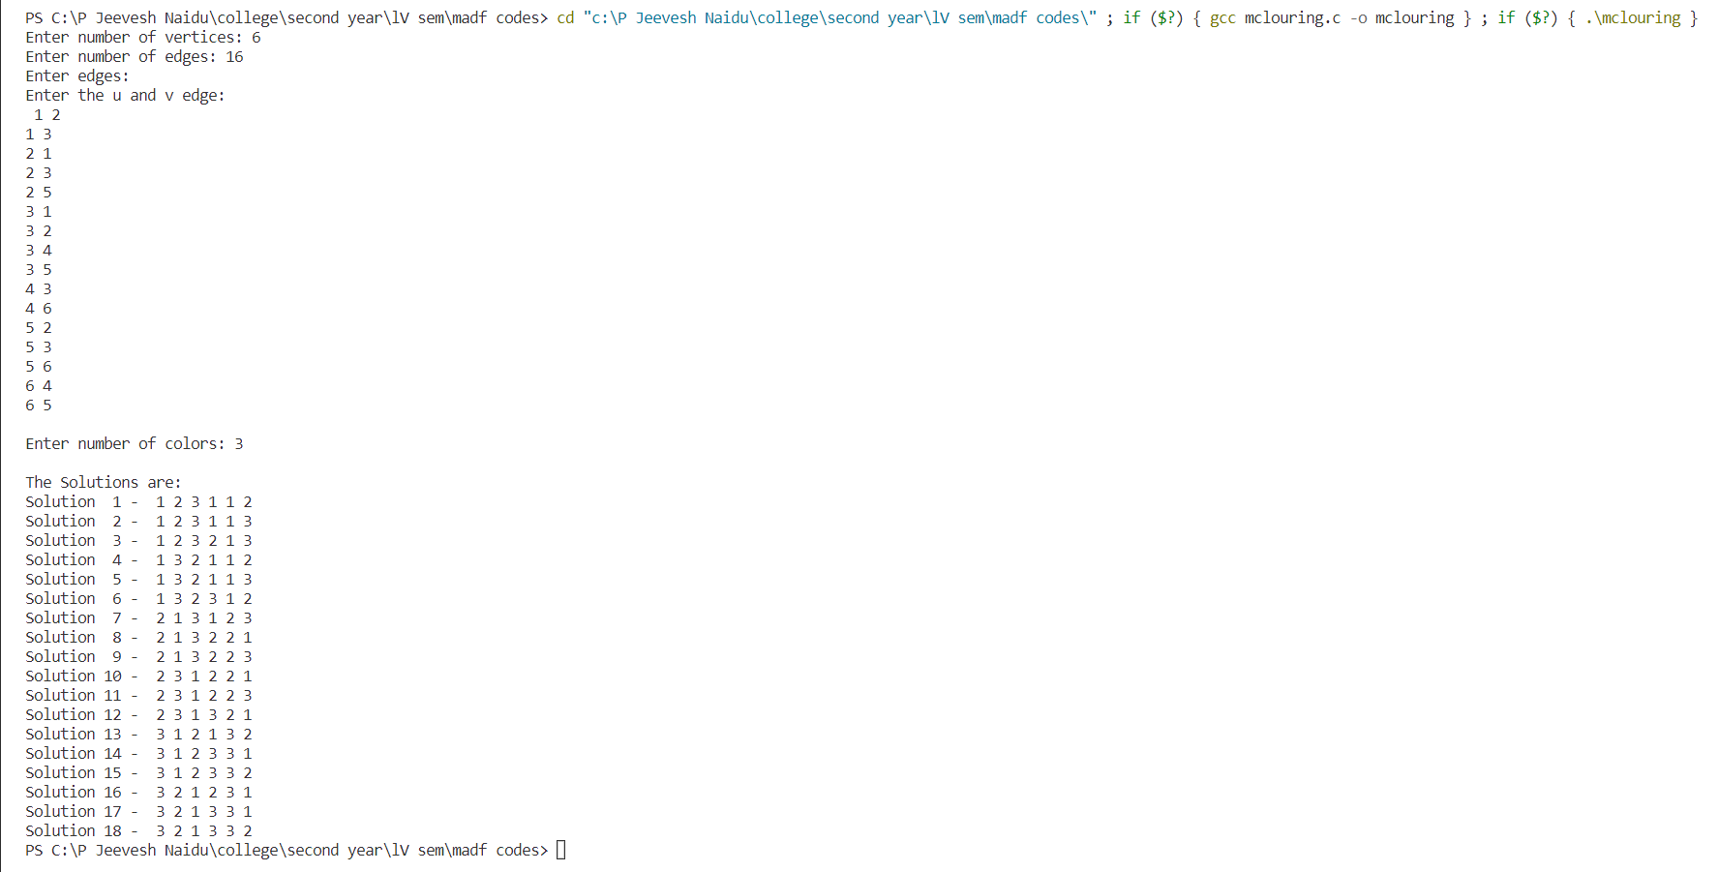

5. **Hamiltonian cycles:**

Input/output:

1]

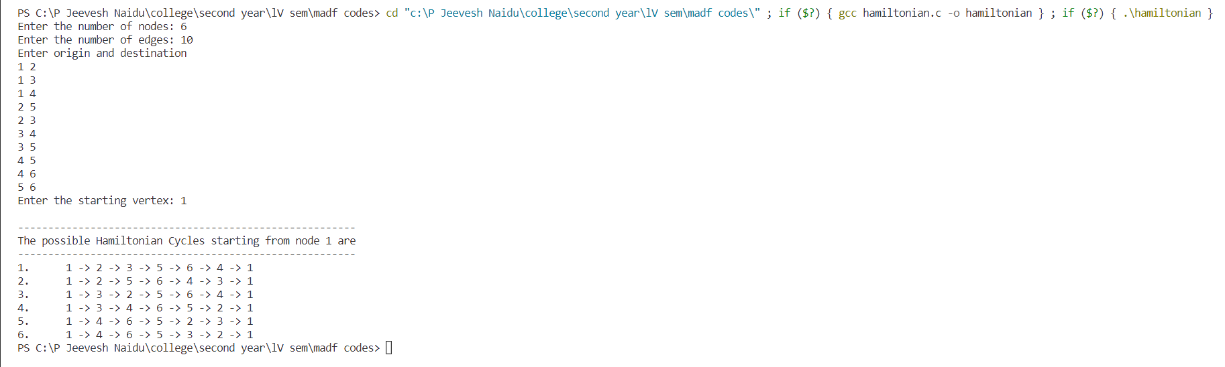

2]

